**Happy Haven Day Care**

**Network Proposal**



Consultant: Christian Hill

**Macro Computer Consultants**

**Overview**

* Cable
  + CAT5e Ethernet Patch Cord, 24 AWG UTP cable
    - 25 bulk pack
    - 1ft
    - $12.96 or 25.92 for two
  + CAT5e Ethernet Patch Cord, 24 AWG UTP cable
    - 25 bulk pack
    - 5ft
    - $24.24
  + CAT5e Ethernet Patch Cord, 24 AWG UTP cable
    - 25 bulk pack
    - 10ft
    - $42.00
  + CAT5e Ethernet Patch Cord, 24 AWG UTP Plenum cable
    - 25 bulk pack
    - 50ft
    - $145.00
  + B-Line J-Hook, 30lb. max load capacity
    - $99.00
  + Nylon 6/6 cable Tie kit, assorted colors, 100 pieces
    - $33.50
* Switch
  + Cisco Small Business 200 series SLM2048T-NA
    - 48 ports
    - Supports up 1000MBPs
    - Supports power over Ethernet (PoE)
    - $428.98
* Server
  + HPE ProLiant ML110 Gen9 tower server
    - Automates the most essential server life cycle management tasks
    - Deploy, update, monitor, and maintain with ease
    - 10 TB SAS/SATA Hard Disk Drive
    - 8 GBs of RAM
    - $872.99
* Server Rack
  + Tripp Lite 12U Wall-Mount Rack Enclosure Cabinet
    - Maximum load capacity of 200 lbs.
    - Swings away from wall on hinge for easy back-door access
    - $322.76
  + 48-Port 2U Rack-Mount Patch Panel
    - functionality and compatibility
    - will save you valuable space in on the rack
    - $87.00
* Server uninterruptible power supply
  + APC BR1500G Backups Pro 1500 VA 10 outlets UPS
    - Guaranteed protection and battery backup power for your valuable electronics, ensuring they remain safe from dangerous power disturbances
    - Guaranteed protection from surges and spikes caused by storms, lightning, circuit overloads, power cycling, etc.
    - $167.32
* Surge protector
  + Tripp Lite Protect it! TLP1008TEL
    - 10 outlets with 2395 joule surge suppressor
    - Lifetime Warranty and $150,000 Ultimate Lifetime Insurance for connected devices.
    - $25.00
* External Hard Drive
  + Seagate Expansion 8 TB External HDD
    - no longer need an extra power source
    - All aluminum enclosure for simplicity and durability
    - $149.99
* Monitors
  + HP 2V2311 23” widescreen LED LCD Monitor
    - VGA
    - Stand included
    - $64.99 each or $1,949.70 for 30 stations
  + Generic VGA Cable
    - $2.49 each or $74.70 for 30 stations

**Class Rooms**

* Workstations
  + HP ProDesk 400 G3 Small Form Factor Desktop PC
    - Windows 10 pro 64
    - 4GB RAM
    - 500GB Hard Drive
    - Keyboard
    - Mouse
    - Warranty
    - $451.94 each or $2,711.64 for 6 workstations

**Computer Lab**

* Work Stations
  + HP ProDesk 400 G3 Small Form Factor Desktop PC
    - Windows 10 pro 64
    - 4GB RAM
    - 500GB Hard Drive
    - DVD ROM
    - Keyboard
    - Mouse
    - $581.15 each or $11,623.00 for 20 stations
* Printer
  + HP LaserJet Pro M501dn Monochrome Laser Printer
    - $399.99
  + HP 87A Black Original LaserJet toner cartridge CF287A
    - Reliable and standard
    - Lasts up to 9,000 pages
    - $236.99 each

**Administration Offices**

* Desktop
  + HP ProDesk 400 G3 Small Form Factor Desktop PC
    - Windows 10 pro 64
    - intel® Core™ i3-6300
    - 4GB RAM
    - 1TB Hard Drive
    - DVD drive
    - Keyboard
    - Mouse
    - $1,250.80 for two
* Printer
  + HP LaserJet Pro MFP M521dn
    - Print, copy, scan, and fax
    - $699.99
  + HP 55X 2-pack High Yield Black Original LaserJet toner cartridges CE255XD
    - Includes 2 cartridges
    - Lasts 12,500 pages per cartridge
    - $450.99

**Security**

* Cameras
  + Zmodo 4 Channel HD Security Camera PoE System
    - Simplified Power over Ethernet means the IP cameras connect to the NVR with a single cable that transmits both data and power, allowing for an easy installation and setup
    - 4 HDMI High Resolution NVR + (4) 720p HD cameras
    - Record up to 100 days for 4 cameras
    - Control and view your security kits from anywhere on your smart phone using the free Zmodo app
    - $229.99

**Software**

* Microsoft Office Products 2016
  + Microsoft Office Home and Business 2016
    - 1 PC (1 License)
    - $105.99 or $2649.75 for 25 computers
* Windows server 2008
  + Windows Essential Business Server 2008
    - Combines several Microsoft server products and technologies into a single, integrated solution
    - Provides tools to create application add-ins and security adapter add-ins to manage additional applications and security issues
    - $0.00 (free as of 2010)
* Security
  + McAfee Complete EndPoint Protection Business
    - an all-in-one solution that provides endpoint security for key devices in your enterprise
    - anti-malware, firewall, device control, and email and web security
    - $129.99
  + McAfee Complete EndPoint Protection Business Licenses
    - 25-50 users and 1 Year Gold Business Support
    - $23.56

**Labor**

* Installation
  + Hourly rate
    - 8 hours * $90 hourly rate = $720 a day
    - After 5-day completion: $3,600.00

**Budget**

* **Cable: 1,000 ft. $193.14**
* **Wireless Access Points: 5 access points $679.95**
* **Router: 1 Router for computer lab $199.99**
* **Switch: 1 switch for the server closet $428.98**
* **Server: For the server closet $1086.99**
* **Server Rack: For the sever closet including the patch panel $409.76**
* **Server uninterruptible power supply: For the server closet $167.32**
* **Surge Protector: for all electronics $25.00**
* **External Hard Drive: for the server closet $149.99**
* **Monitors/VGA cables: for 30 workstations $2,024.40**
* **Employee Workstations: 6 for each classroom $2,711.64**
* **Computer Lab Workstations: 20 for the Computer Lab $11,623.00**
* **Admin Desktop: For both Admin office $1250.80**
* **Docking station: For laptop in front admins office $94.99**
* **Printers:1 in Admin’s office and 1 in the Computer Lab $1,099.98**
* **Printer ink: for both printers $687.98**
* **Camera System: 4 cameras for the building $299.99**
* **Microsoft Office Home and Business 2016: for 25 computers $2,649.75**
* **Windows Server 2008: software and licenses $0.00**
* **Internet Security: McAfee security including 50 licenses $153.55**
* **Labor: My work for 5 days $3,600.00**

**TOTAL: $29,537.20**

**Legend**

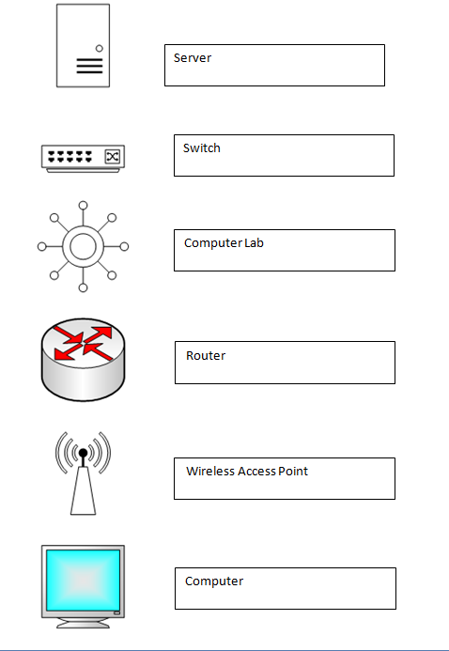

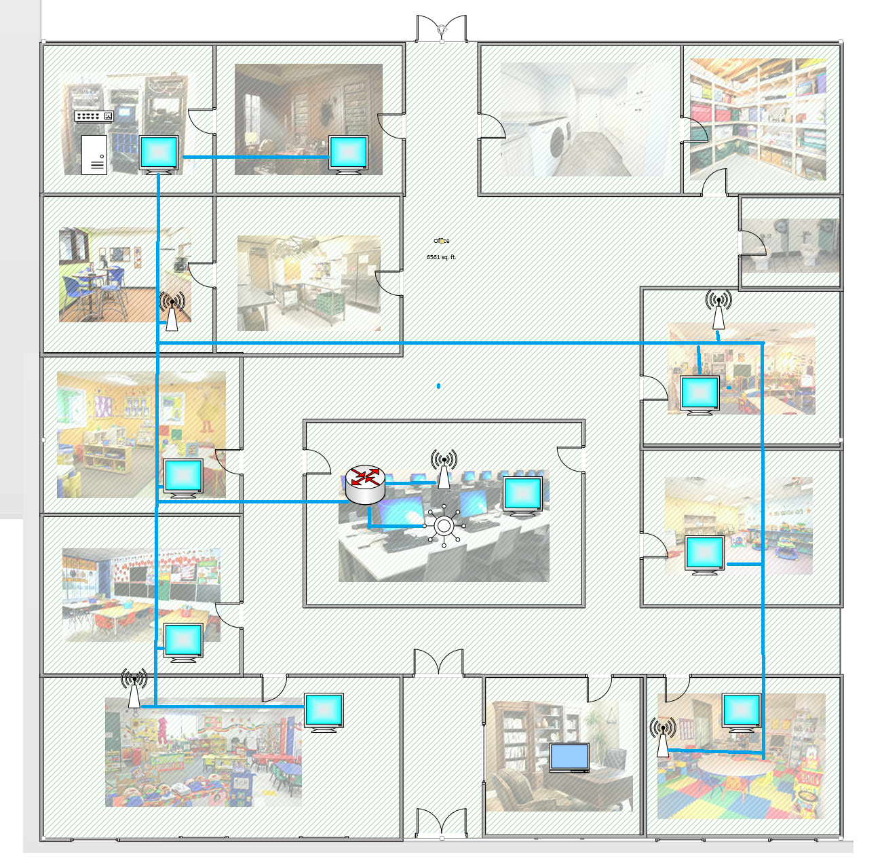

**Notes**

_____________________________________________________________________________________________________________________________________________________________________________________________________________________________________________________________________________________________________________________________________________________________________________________________________________________________________________________________

_____________________________________________________________________________________________________________________________________________________________________________________________________________________________________________________________________________________________________________________________________________________________________________________________________________________________________________________________

_____________________________________________________________________________________________________________________________________________________________________________________________________________________________________________________________________________________________________________________________________________________________________________________________________________________________________________________________

_____________________________________________________________________________________________________________________________________________________________________________________________________________________________________________________________________________________________________________________________________________________________________________________________________________________________________________________________

_____________________________________________________________________________________________________________________________________________________________________________________________________________________________________________________________________________________________________________________________________________________________________________________________________________________________________________________________

_____________________________________________________________________________________________________________________________________________________________________________________________________________________________________________________________________________________________________________________________________________________________________________________________________________________________________________________________